Review Ranking System based on Utility

*Abstract*— In recent years with the advancement of technology the online shopping has been marked as a convenient shopping place because of the cheap price, variety of products, easy comparison and easy understanding about the products by different customer reviews. Customers post their experience (good/bad) about the product which helps others to decide whether the item is good for purchase or not. This is also essential for the manufacturer to understand the market demand to improve their product. But is it feasible to read all reviews? There are thousands of reviews for each product, some are important and some are not giving enough information about the product. In this paper, we are proposing a novel method to rank relevant and valuable reviews. We believe this research will help customers as well as manufacturers to understand broadly about the product in a quick time. This will help the customer to save a lot of time to choose whether to purchase the product or not. Also, it may help the manufacturer to come up with new ideas which may meet the customer satisfaction.

Keywords—Reviews Ranking, helpfulness of review, upvotes, downvotes, ratings

# Introduction

The demand for online purchase is increasing day by day because people want to shop without much hassle. People can purchase a product anytime from anywhere without facing the crowd, also having the advantages to explore a variety of different products in the same place at a competitive price. Customers also share their valuable feedback about their purchased products in the form of reviews and ratings. These reviews are also evaluated by other customers by upvoting or downvoting them.

These reviews are helpful in many ways, for example, when someone wishes to buy a new product, they can estimate whether the product is apt for them by reading the reviews. This will make it easy for them to understand the pros and cons of the product and accordingly they can decide whether to buy the product or not. Also, these reviews are helpful for the manufacturers to understand the customer’s sentiment. This may help the manufacturers to modify the product as per the customer’s needs to sustain in the aggressive market.

There may be thousands of different opinions of customers. Some of the reviews are intended to understand the pros and cons of a product while others are not much beneficial. It is cumbersome to go through all the reviews to understand the product. However, we can read a small number of the most relevant and meaningful reviews to have a quicker understanding of the product.

The application can be utilized by customers as well as manufacturers to assess only the most useful reviews to take relevant business decisions.

# Relevant work

We can find many related works based on review ranking. We are very much inspired by the previous works. Prior works are done on review sentiments in online reviews. Also, previous works continue with average ratings, No. of upvote and downvote, of reviews to find the most important review. But it does not consider how a comment is impacted with Upvotes if the reviewer attached any photos. To best of our knowledge, no prior work has taken no of photos, gender under consideration to find relevant, important reviews. With These extra features our research help to find most important reviews not only based on average ratings and no of (upvotes, downvotes) but also taking consideration of no. of photos and gender which are highly correlated with review ratings.

# Methodology

Figure 1 gives the architectural overview of our review helpfulness system. The input to the system is the reviews of the product given by the customers, whereas the output is the score got by the reviews taking into consideration various features.

## Target Variable

Ranking the reviews based on helpfulness is being measured by upvotes and downvotes provided by the users on the reviews.

The target variable created for this purpose is as follows:

$$h=\frac{upvotes}{upvotes+downvotes}$$

Higher value of h suggests the review is more helpful

## Other variables from the data which are considered:

# 1) Review Title

# 2) Review Text

# 3) Review Rating

# 4) Gender

**Review Title:** Whenever the user provides a review, a title to the review is provided which generally describes the review.

**Review Text:** Under review title, user provides the review in descriptive manner about his opinion of the product. Below is a sample of the same:

**Review Rating:** While providing the review, users also provide a quantitative measure for the product. In general, the rating is in between 1 to 5 considering 5 as highest.

**Gender:** Gender is tagged manually using the name of the reviewers.

**No. of photos uploaded:** A picture can speak a thousand words. Hence photos uploaded by the users are also considered to determine if the reviews are helpful

Fig 1 gives the architectural overview of our Review ranking system. Where the input are all the reviews about a product. And our output is useful reviews.

This system helps to give us top valuable and meaningful reviews based on different features of a product.

These system works in following steps:

### We receive all the reviews of a product.

### Cleaning of all the product reviews.

### Finding the unigrams.

### Finding the important features of the product.

### Train the model based on unigram and features.

## **Spelling correction**:

In the reviews there are many words which are incorrectly spelled. Some of these words may be really important. So, we used TextBlob library to correct the words. This will help us to identify important features and Unigram.

## **Remove Stop Words:**

There are many repeated words which are not important. So, we remove them to get exact ideas out of review. We created two different columns:

1) len_before which is a length of review before removing the words.

2)len_after which is a length of review after removing the words.

## **POS Tagging:**

Parts of speech tagging is important because we need to find % of (Nouns, Verb, Adjective, Adverb) to understand the feature importance. We use POS tag from Spacy library in python to produce parts of speech tags for every word. Then we find percentage of noun, verb, adjective, adverb for each review and create a dataset.

We also add features like the number of emojis per review, number of photos per review, number of exclamation mark, number of question mark.

## **Modeling:**

For modeling purpose, we split the data into train and test and then fit different models to check accuracy.

# EXPERIMENTS

In this section, we describe our experiments with classification-based approach for ranking the review helpfulness. We evaluate our model by comparing the performance of various features on the reviews extracted from flipkart

***Experimental setup:***

We extracted the described dataset from flipkart with the help of UI Path studio which is an RPA tool and performed all the further analysis and the model implementation on the same.

***Data Preprocessing:***

We used Spacy library to create features such as Length of review, Number of sentences, Number of emoticons used, Number of exclamation marks, Number of Question marks etc.

We identified that most of the reviews were of length between 1-70 words. The average length of the reviews was about 52 words per review. The average number of sentences was 4. We found that there were very a small number of reviews that used exclamation or question marks. Also, not many reviewers have used Proper Case in their reviews. For reviews more than 500 characters that was under read more section, the reviews were extracted manually for them.

We removed stop words, punctuations, emoticons and spell check. Also, we removed those reviews that had less than 2-3 words in it as those reviews would not be much of the help for training the model.

We applied POS and NER tagging. We used TF-IDF Vectorizer to create a TF-IDF matrix.

We also created the target variable named ‘h’ which is used to rank the reviews and is calculated as below:

$$h=\frac{upvotes}{upvotes+downvotes}$$

The TF-IDF matrix thus created consisted of all the unique words found in all the reviews as columns plus the columns we created during feature engineering stage. For iphone7, for a total of 264 reviews, we had a total of 1610 unique words.

***Data Modelling:***

Considering the problem as regression problem, we experimented with various machine learning regression models like SVR, Elastic net, XG Boost and Random Forest.

We also used Vader Sentiment Analysis for getting the review sentiments such as positive, negative or neutral and found that a few of the users who have rated the product very low (less than 2 ratings) have positive sentiments. On checking the reviews of these users manually we found that the reviews were actually positive but the ratings given were less. This can be misleading. Thus, Vader sentiment analysis helps in identifying the sentiment based on the content of the reviews provided by the customers.

We have used MAPE to compare the models and identify the best model among them. Below is a table of the models used and the MAPE obtained from the same.

|  |  |  |
| --- | --- | --- |
| **Sl. No.** | **Model** | **MAPE** |
| 1 | SVR |  |
| 2 | Elastic net |  |
| 3 | Random Forest |  |
| 4 | XG Boost |  |

***User Interface:***

To make it more user friendly we have provided a user interface which would help the user to pass the filpkart url of the product and the program at the backend can run the algorithm separate the positive and negative reviews and rank them as per their predicted helpfulness. After the completion of the process, the files are stored at the desired location provided by the user.

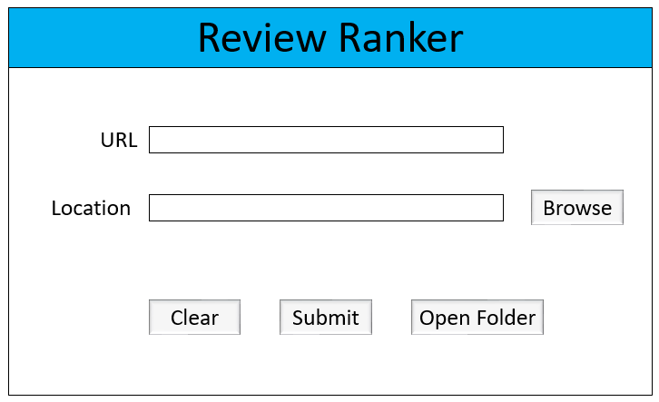We have used ‘Tkinter’ library to create GUI for our project.

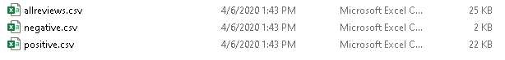This system outputs 3 csv files namely: allreviews, negative and positive each containing reviews which are ranked.

FINDINGS

##### 1) We have observed that some reviewers have used photos in their reviews which are getting more upvotes. Also, for reviews by a particular gender, people are giving more upvotes.

##### 2) We have seen that there are also many recent comments which are also important but didn’t get more likes as compared to old comments.

##### 3) Some comments are using only emojis, which are not giving proper understanding of the product.

# CONCLUSION

In online shopping, reviews are play a vital role. Reviews are the opinions of the individual customer. So, when a customer wants to purchase a new product, he/she always consider other people’s opinion before investing in it. So, in this paper, we propose a technique to rank the most suitable reviews about the product based on features. We have evaluated this method on a review dataset of a mobile phone of a popular brand and rank according to most critical reviews. A time-saving approach is always helping mankind. We hope our method will help millions of customers and manufacturers and save their time to understand the product.

##### References

1) Justeson, J. S., and Katz, S.M, “Technical Terminology: some linguistic properties and an algorithm for identification in text,” Natural Language Engineering 1(1):9-27, 1995.

4) Kim, S.-M., and Hovy, E. Determining the sentiment of

opinions. In Proceedings of the 20th International Conference on Computational Linguistics (COLING 2004) (2004),

pp. 1367–1373.

5) Nigam, K., and Hurst, M. Towards a robust metric of opinion. In AAAI Spring Symposium on Exploring Attitude and Affect in Text (2004), pp. 598–603

6) Wilson, T., Wiebe, J., and Hwa, R. Recognizing strong

and weak opinion cla uses. Computational Intelligence 22, 2

(May 2006), 73–99.

7) Rohm, A.J., & Swaminathan, V., “A typology of online shoppers based

on shopping motivations,” Journal of Business Research, 57, 748-757,

2004.

.

2) Dave, K., Lawrence, S., and Pennock, D. M. Mining

the peanut gallery: Opinion extraction and semantic

classification of product reviews. In Proceedings of the

12th International World Wide Web Conference (WW

W12) (2003) p. 519–528.

3) Ward, J.H., “Hierarchical grouping to optimize an

objective function,” Journal of the American Statistical

Association, 58, 236–244, 1963.